**MySQL Assignment -1 (DDL)**

**Login to MySQL and view all databases already present. You should get following result :**

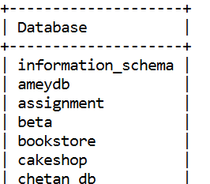

**Ans:**

mysql> show databases;

+--------------------+

| Database |

+--------------------+

| 1ddl |

| 1sql |

| information_schema |

| mysql |

| performance_schema |

| sys |

+--------------------+

6 rows in set (0.00 sec)

**Write an SQL statement to create a simple table countries including columns country_id,country_name and region_id. After this display the structure of table as below :**

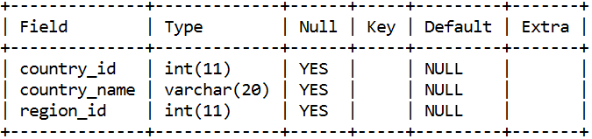

**Ans:**

mysql> create table countries(

-> country_id int (11),

-> country_name varchar(20),

-> region_id int (11));

Query OK, 0 rows affected, 2 warnings (0.12 sec)

mysql> desc countries;

+--------------+-------------+------+-----+---------+-------+

| Field | Type | Null | Key | Default | Extra |

+--------------+-------------+------+-----+---------+-------+

| country_id | int | YES | | NULL | |

| country_name | varchar(20) | YES | | NULL | |

| region_id | int | YES | | NULL | |

+--------------+-------------+------+-----+---------+-------+

3 rows in set (0.03 sec)

**Write an SQL statement to create a table named jobs including columns job_id, job_title, min_salary, max_salary and check whether the max_salary amount exceeding the upper limit 25000. Also set job_id as primary key and entering null values for job_title is not allowed.**

**Ans:**

mysql> create table jobs(job_id varchar(10) primary key,job_title varchar(20) not null,min_salary decimal(6,0),max_salary decimal(6,0),constraint check(max_salary<=25000));

Query OK, 0 rows affected (0.32 sec)

mysql> desc jobs;

+------------+--------------+------+-----+---------+-------+

| Field | Type | Null | Key | Default | Extra |

+------------+--------------+------+-----+---------+-------+

| job_id | varchar(10) | NO | PRI | NULL | |

| job_title | varchar(20) | NO | | NULL | |

| min_salary | decimal(6,0) | YES | | NULL | |

| max_salary | decimal(6,0) | YES | | NULL | |

+------------+--------------+------+-----+---------+-------+

4 rows in set (0.00 sec)

**Write a SQL statement to create a table named job_history including columns employee_id, start_date, end_date, job_id and department_id**

**Ans:**

mysql> create table job_history(employee_id decimal(6,0),start_date date,end_date date,job_id varchar(10),department_id decimal(4,0));

Query OK, 0 rows affected (0.15 sec)

mysql> desc job_history;

+---------------+--------------+------+-----+---------+-------+

| Field | Type | Null | Key | Default | Extra |

+---------------+--------------+------+-----+---------+-------+

| employee_id | decimal(6,0) | YES | | NULL | |

| start_date | date | YES | | NULL | |

| end_date | date | YES | | NULL | |

| job_id | varchar(10) | YES | | NULL | |

| department_id | decimal(4,0) | YES | | NULL | |

+---------------+--------------+------+-----+---------+-------+

5 rows in set (0.00 sec)

**Write an SQL statement to alter a table named countries to make sure that no duplicate data against column country_id will be allowed at the time of insertion.**

**Ans:**

mysql> alter table countries

-> modify country_id varchar(20) unique;

Query OK, 0 rows affected (0.37 sec)

Records: 0 Duplicates: 0 Warnings: 0

mysql> desc countries;

+--------------+-------------+------+-----+---------+-------+

| Field | Type | Null | Key | Default | Extra |

+--------------+-------------+------+-----+---------+-------+

| country_id | varchar(20) | YES | UNI | NULL | |

| country_name | varchar(20) | YES | | NULL | |

| region_id | int | YES | | NULL | |

+--------------+-------------+------+-----+---------+-------+

3 rows in set (0.00 sec)

**Write an SQL statement to create a table named jobs including columns job_id, job_title, min_salary and max_salary, and make sure that, the default value for job_title is blank and min_salary is 8000 and max_salary is NULL will be entered automatically at the time of insertion if no value assigned for the specified columns.**

**Ans:**

mysql> create table jobs(job_id varchar(20),job_title varchar(20) default ' ',min_salary decimal(6,0) default 8000,max_salary decimal(6,0) default NULL);

Query OK, 0 rows affected (0.12 sec)

mysql> desc jobs;

+------------+--------------+------+-----+---------+-------+

| Field | Type | Null | Key | Default | Extra |

+------------+--------------+------+-----+---------+-------+

| job_id | varchar(20) | YES | | NULL | |

| job_title | varchar(20) | YES | | | |

| min_salary | decimal(6,0) | YES | | 8000 | |

| max_salary | decimal(6,0) | YES | | NULL | |

+------------+--------------+------+-----+---------+-------+

4 rows in set (0.00 sec)

**Create a Department table with following structure**

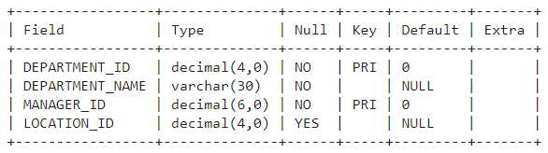

**Ans:**

mysql> create table Department(DEPARTMENT_ID decimal(4,0) not null default 0,DEPARTMENT_NAME varchar(30) not null ,MANAGER_ID decimal(6,0) not null default 0,LOCATION_ID decimal(4,0));

Query OK, 0 rows affected (0.72 sec)

mysql> alter table department add PRIMARY KEY(DEPARTMENT_ID,MANAGER_ID);

Query OK, 0 rows affected (0.39 sec)

Records: 0 Duplicates: 0 Warnings: 0

mysql> desc department;

+-----------------+--------------+------+-----+---------+-------+

| Field | Type | Null | Key | Default | Extra |

+-----------------+--------------+------+-----+---------+-------+

| DEPARTMENT_ID | decimal(4,0) | NO | PRI | 0 | |

| DEPARTMENT_NAME | varchar(30) | NO | | NULL | |

| MANAGER_ID | decimal(6,0) | NO | PRI | 0 | |

| LOCATION_ID | decimal(4,0) | YES | | NULL | |

+-----------------+--------------+------+-----+---------+-------+

4 rows in set (0.00 sec)

**Write an SQL statement to create a table employees including columns employee_id, first_name, last_name, email, phone_number hire_date, job_id, salary, commission, manager_id and department_id and make sure that, the employee_id column does not contain any duplicate value at the time of insertion and the foreign key columns combined by department_id and manager_id columns contain only those unique combination values, which combinations are exists in the departments table.**

**Ans:**

mysql> create table Employees(EMPLOYEE_ID decimal(6,0)not null PRIMARY KEY,FIRST_NAME varchar(20)DEFAULT NULL,LAST_NAME varchar(25)NOT NULL,EMAIL varchar(25)NOT NULL,PHONE_NUMBER varchar(20)DEFAULT NULL,HIRE_DATE date NOT NULL,JOB_ID varchar(10)NOT NULL,SALARY decimal(8,2)DEFAULT NULL,COMMISION_PCT decimal(2,2)DEFAULT NULL,MANAGER_ID decimal(6,0)DEFAULT NULL,DEPARTMENT_ID decimal(4,0)DEFAULT NULL,FOREIGN KEY(DEPARTMENT_ID,MANAGER_ID) REFERENCES department(DEPARTMENT_ID,MANAGER_ID));

Query OK, 0 rows affected (0.57 sec)

mysql> desc Employees;

+---------------+--------------+------+-----+---------+-------+

| Field | Type | Null | Key | Default | Extra |

+---------------+--------------+------+-----+---------+-------+

| EMPLOYEE_ID | decimal(6,0) | NO | PRI | NULL | |

| FIRST_NAME | varchar(20) | YES | | NULL | |

| LAST_NAME | varchar(25) | NO | | NULL | |

| EMAIL | varchar(25) | NO | | NULL | |

| PHONE_NUMBER | varchar(20) | YES | | NULL | |

| HIRE_DATE | date | NO | | NULL | |

| JOB_ID | varchar(10) | NO | | NULL | |

| SALARY | decimal(8,2) | YES | | NULL | |

| COMMISION_PCT | decimal(2,2) | YES | | NULL | |

| MANAGER_ID | decimal(6,0) | YES | | NULL | |

| DEPARTMENT_ID | decimal(4,0) | YES | MUL | NULL | |

+---------------+--------------+------+-----+---------+-------+

11 rows in set (0.00 sec)